Plagiarism and Misrepresentation

Academic integrity and honesty is YOUR RESPONSIBILITY.

We will use the Stanford University Student Ethics Policy as our guide.

“For purposes of the Stanford University Honor Code, plagiarism is defined as the use, without giving reasonable and appropriate credit to or acknowledging the author or source, of another person's original work, whether such work is made up of code, formulas, ideas, language, research, strategies, writing or other form(s).”

If you have an idea from another source, you must give them credit. Should you ignore or dismiss your personal responsibility to academic integrity, the consequences are severe, including but not limited to failure of any part or parts of the project or failure of the project.

What constitutes plagiarism?

In addition to the instruction provided by your teacher, the list that follows is a brief outline of what characterizes plagiarism.

1. Directly copying (more than three words) from another source without giving credit to the author.
2. Incorrectly citing or failing to cite your sources at appropriate times.
3. Not paraphrasing the information completely or correctly.
4. Using another person’s work, in part or as a whole, as your own.
5. Using work that you have completed for another teacher without approval. (You may expand upon previous research, but you must have approval and submit a copy of the original research first.)
6. An incomplete or missing Works Cited page that does not provide enough information for source verification. (Your teacher may require you to provide copies of all resources used in a research folder for further source verification.)
7. Passing on your work to another student in another class and/or in another school.

What is misrepresentation?

1. Claiming you have no previous experience or knowledge in each area when you actually do.
2. Falsifying documents, signatures, or assignments.
3. Using a family member as a mentor or interview subject.
4. Allowing other people to complete portions of your assignments.
5. Committing any other breach of the project assignment requirements.

Plagiarism and Misrepresentation Contract

Intern Name: ___________________________________________
(printed)

I have read the plagiarism and misrepresentation policy. I understand that if I am caught plagiarizing in any way during my completion of the STAX3D Internship, I will receive a formal written warning at a minimum and it may result in the termination of my internship.

I give my word that I will be honest during the entire process.

Intern Signature: ____________________________________________ Date: __________

Project Documentation

Your notebook is documentation of all the hours you have put in and everything you have done for your project. It “tells the story” of what has been done every step of the way. The following are guidelines for what your journal needs to include and what it should look like when it is finished. There will be a notebook check each Friday.

Layout - The notebook layout has been provided. It may be changed by you as needed, but as guidelines:The problem definition should include a description of the problem you are trying to solve and the question(s) you will answer. Describe why this problem is relevant and who wants to know the answer and why. Show that this problem is important
- The project proposal should contain a description of how you will solve the problem presented in the problem definition. Explain what steps you will take to solve it, and what your process will be. These two could be combined
- As you execute your proposed method of solving the problem, place all files generated in the relevant folder. Everything you do should result in digital files that can be documented.
- Take notes of what you accomplish as you are working for reference if you need to recall something you did previously. These will also serve as the basis for writeups and presentations
The following must also be evident, but it is not necessary to include all criteria in each entry.
- Resources to help you complete the activity (materials, individuals to contact, locations to visit)
- Notes of the pages of books or print outs of the internet sources you used. The actual copies or printouts will be included in your portfolio.
- Planned steps (what you did, what you saw, what you heard)
- Reflections (what you learned, how the activity related to your project)
- Modifications you made to your original plan
- Evidence that demonstrates successful completion of activity
- Anything else that you did to help complete the project.

A non-example would be:
September 16, 2012
I met my mentor and we talked about my project. Worked on my proposal. Made a journal entry.
Total hours: 5

An example of an appropriate journal entry:
September 16, 2012
Today, I met with my mentor for the first time for about an hour. My mentor is a mechanic who specializes in Ford engines. I told him about my plan to rebuild my '67 Mustang engine and put it in my car. I told him what I think the problems are, which are that the block is cracked, the engine needs new heads and pistons, and the carburetor is damaged and needs new parts. My mentor agreed to come look at the engine next week on Wednesday, so we can determine if there is anything else that is wrong and figure out approximately how much this is going to cost me. The second hour I spent working on my proposal. I'm having trouble deciding how I am going to research engines and exactly what I need to learn to complete this project. I also typed my overview, so I can show it to my teacher tomorrow. I hope she approves it! All of my work today related to Applied Learning 1b--I'm improving a system (my car engine). See portfolio pictures pages 19-21 and other documentation on pages 4-6.
(Journal examples adapted from Mountlake Terrace High School Journal Guidelines

Notebook Checklist
As you record your activities in the project, ask yourself, "Did I..."
- Keep up with the table of contents?
- Date each page or each new entry?
- Number each page consecutively?
- Use continuation notes when necessary?
- Properly void all blank pages or portions of pages (front and back)?
- Enter all information directly into the notebook?
- If a mistake is made do not scribble it out. Cross it out with a single line or an X if it is a larger mistake?
- Draw a line across the bottom of an entry to indicate that this day is over?
- Refer to the correct place in the portfolio to show evidence that supports the entry, if proof is not included in the notebook?
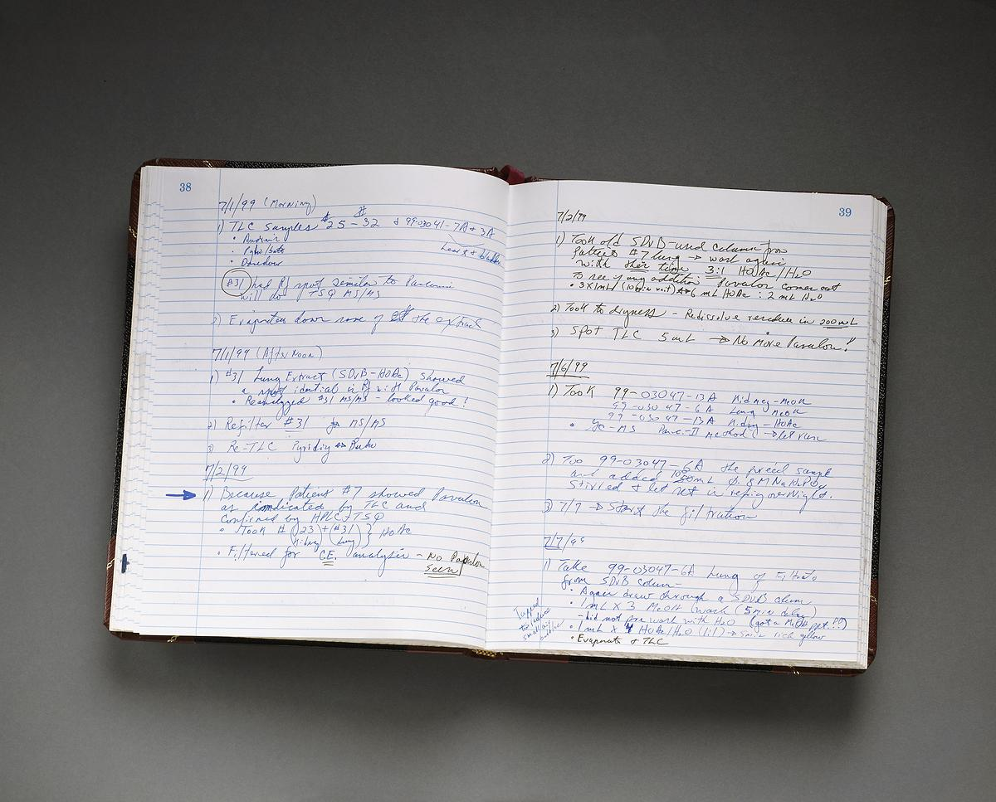

Internship Verification Log

DATE | TIME IN | TIME OUT | ACTIVITES | ADVISOR  SIGNATURE
Project Proposal

Title of Experience
Author(s)
Include your name and any program affiliation.
Section I: Purpose Statement and Title
- Guidelines: Write one or two sentences specifically stating the expected outcome or the goal of the project. It may be in the form of a hypothesis or a description.
- Use few words.
- Be direct.
- Create the title directly from the purpose statement and use one sentence.
- Example:
- Title: A Teenager’s Guide to Healthy Eating
- Purpose Statement: Teenagers at risk for type 2 diabetes need support and direction to make wise dietary choices daily. A dietary handbook, designed specifically for teens, will be created and made available through the National Diabetes Association.
Section II: Literature Review

The literature review section provides background information about the topic/problem you’ve chosen.
- It should be approximately two to three pages in length.
- It is intended to provide the reader with enough details to be able to understand the topic.
- It should answer the following questions:
  - What are some problems related to this topic? List and explain at least 5 specific problems that are related to this area of health care?
  - What knowledge already exists about this topic?
  - What gaps are there in existing knowledge regarding this topic?
  - What information is currently known about the problem (i.e., identify the existence of the problem as well the significance of the problem)?
  - Why is it important to address the problem?
  - What solutions were available in the past?
  - What solutions are currently available for the problem?
  - What are some possible solutions that could be done in the future?

DO NOT DISCUSS WHAT YOU WILL DO OR YOUR SOLUTION TO THE PROBLEM. DISCUSS WHAT HAS BEEN DONE AND THE GAPS. THIS WILL SUPPORT THE ACTUAL NEED FOR YOUR PROBLEM AND YOUR SOLUTIONS IN SUBSEQUESNT ACTIVITIES.
- Arouse the reader’s interest and support for the project.

Section III: Problem Statement (background and significance)
- Guidelines: Write one page that clearly identifies why the project is needed and how the outcome addresses the need.
- Give clear evidence, with data, supporting the need for the work.
- Prove that the work is important.
- Identify previous work that has been done to address this problem and show why more work is needed.
Section IV: Project Goals
- Guidelines: The proposal should have one or two goals that are clearly stated and that describe the outcome of the work.
- Goals are general and idealistic.
- Goals are not necessarily directly measurable.
- Goals identify the focus of the work.
- Example Goal:
- Improve the health of teenagers by changing their eating habits.
Section V: Project Objectives
- Guidelines: The proposal should include three to four objectives that clarify how the goals from the previous section will be achieved.
- Objectives are very specific.
- Objectives are measurable.
- Each objective includes specific actions designed to attain that objective.
- With each objective is an explanation of how it will be evaluated.
- Example Objective:
- Decrease the incidence of type 2 diabetes in teenagers by 25%.
Section VI: Project Methodology (details)
- Guidelines: Write three to four pages outlining the procedure to reach the project’s goals and objectives.
- Procedure: The proposal should include detailed steps of how the work will be carried out as well as the specific outcomes expected after portions of the work have been completed. The outcomes should be directly related to the goals and objectives.
- Write detailed steps.
- Include who is responsible for each step.
- Include how each step is to be completed.
- Include a time frame for each step.
- Include a description of the necessary resources.
- Include a description of the implementation process.
- Include your Gant Chart.
Section VII: Cost Analysis
Write out a detailed plan accounting or all costs for your project. Indicate if it will be donated or cost money and where you will obtain the funding.
Section VIII: Summary and Evaluation
- Guidelines: Assume the proposal is approved and write one to two pages that summarize the project and indicate how it will be evaluated.
- Summarize the positive impact this project will have on the target group.
- Suggest a detailed strategy that could be used to evaluate the work over the short term (within a year). Be specific. For example, will there be statistics and numerical evidence? How will the evidence be collected?
- Suggest a detailed strategy that could be used to evaluate the work over the long term (over several years). Be specific. For example, will there be statistics and numerical evidence? How will the evidence be collected?
- Relate all evaluation strategies directly to the goals and objectives of the proposal.
Section IX: Project Proposal Sources
- Guidelines: Create a documentation page citing all sources used to create this proposal.
- Use correct APA documentation format.
- Use a minimum of five valid sources.
Project Final Report (We can work on the format of this later)
Section III: Abstract
- Guidelines: Write a summary of the work which introduces the reader to the project, creates interest and enthusiasm, and invokes in the reader a sense of importance for the project.
- Write two or three paragraphs.
- Repeat the purpose statement.
- Be concise and specific with few details.
- Show strong direction and purpose.

Section X: Project Poster

